TASK 2:

Create a public repo HAZESOFT-T2 in your github account.

Create a VM in your PC, HInt: you can use virtualbox or KVM for creating VM

Using Ansible, deploy above TASK 1 in that VM.

OUTPUT:

when we run the ansible-playbook command, that should be deployed automatically.

When we ssh to VM and run curl http://localhost:9000/site/index.html, we must see the message "You did it, Congratulations!!" .

……………………………………………………………………………………………………………

Firstly I have created the HAZESOFT-T2 repo in the github account.

Then I install the virtual box using the following command

Sudo apt update && sudo apt install virtualbox.

Once completed to run the virtualbox in the host computer, we use the command “virtualbox”.

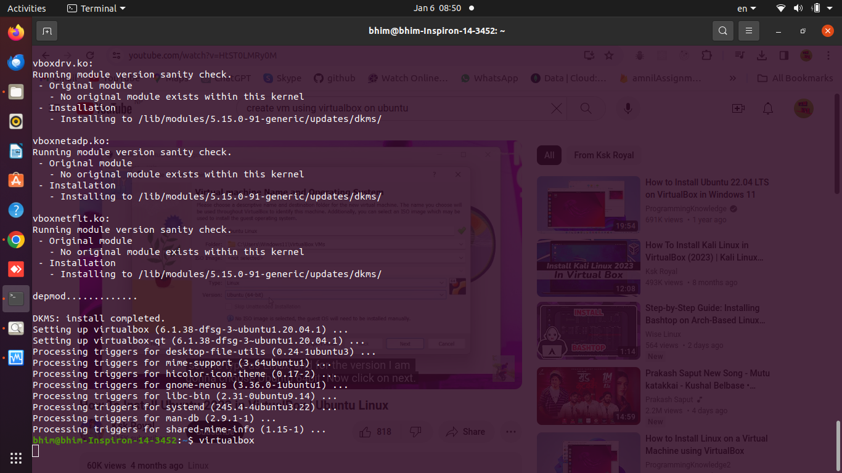

Then we configure the setting and allocated memory as per the requirements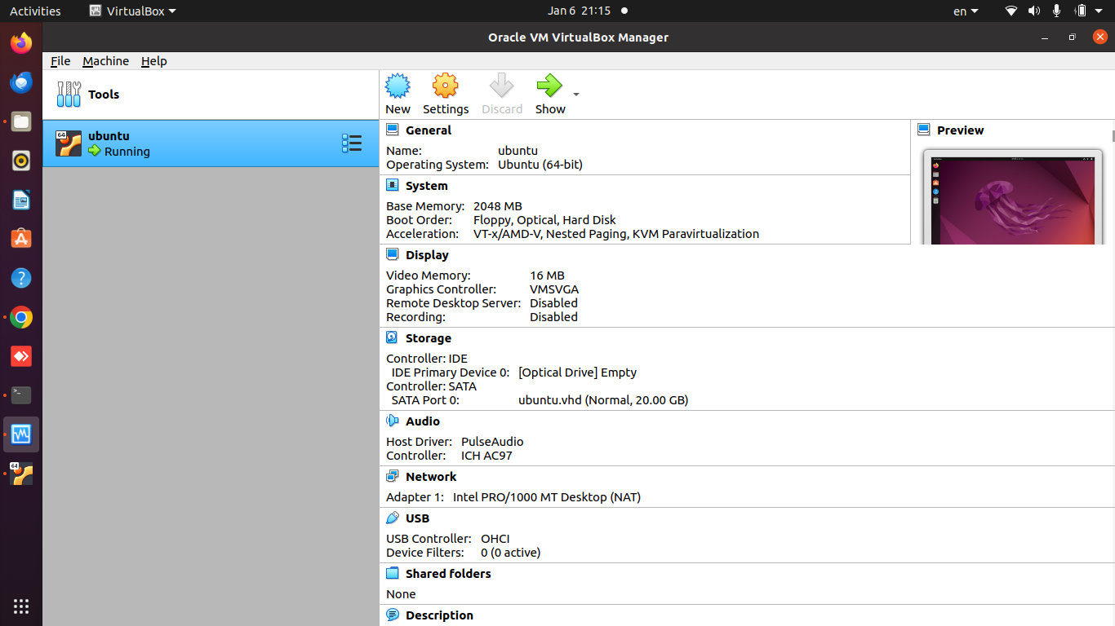

In that virtual box, we then run the terminal by pressing alt+ctrl+t

Then we install ansible using the following command.  
sudo apt update && sudo apt install ansible

Then we create the hazesoft directory using following command

mkdir hazesoft

Then we go in that directory using the following command

cd hazesoft

Inside that directory we create the inventory named as “deploy.yml” and add some commands.

---

- name: Deploy HAZESOFT-1 on VM

hosts: 10.0.2.15

become: true

remote_user: bhim

vars:

ansible_ssh_private_key_file: "~/.ssh/id_rsa.pub"

tasks:

- name: Install Docker

apt:

name: docker.io

state: present

- name: Install Docker Compose

apt:

name: docker-compose

state: present

- name: Clone the repository

git:

repo: https://github.com/veekrum/task

dest: /tmp/task

- name: Build Docker Image

command: docker build -t hazesoft-1 /tmp/task

- name: Run Docker container

docker_container:

name: hazesoft-t1-container

image: hazesoft-1

ports:

- "9000:80"

become: true

Then save it…

In the terminal run the following command..

Ansible-playbook -i 10.0.2.15, deploy.yml

